# Lab Guide for BYO dCloud SRv6 Lab

## Part 1 – dCloud Topology Builder Tool

1. dCloud Topology Builder:

<https://tbv3-ui.ciscodcloud.com/>

1. CEC login if prompted
2. Select “Topologies”:

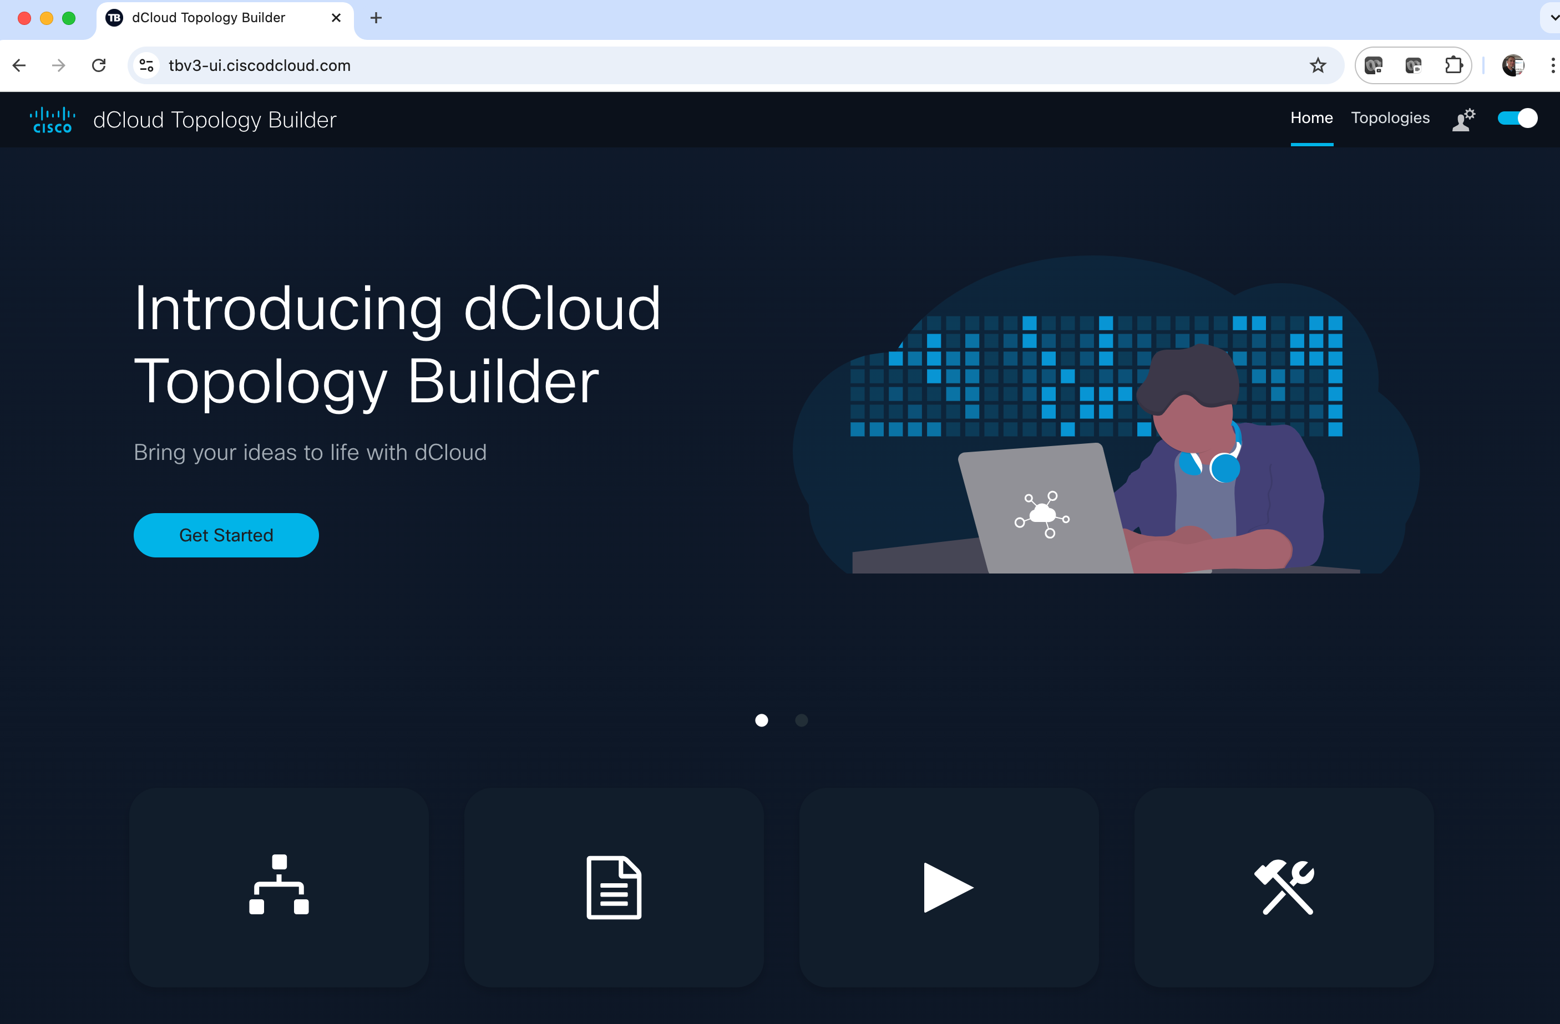

1. In the My Topologies screen select “Create”

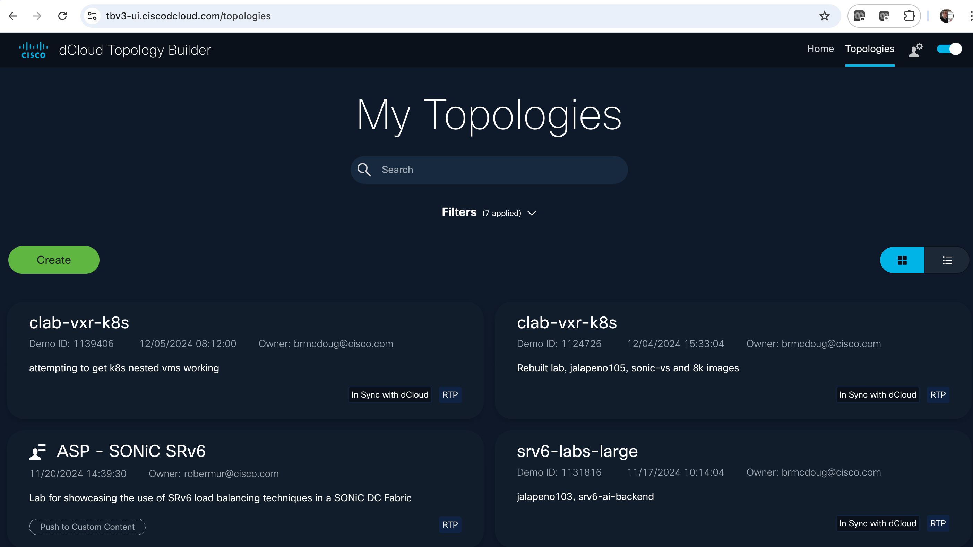

1. Then select a Data Center to host your topology (US East or West)

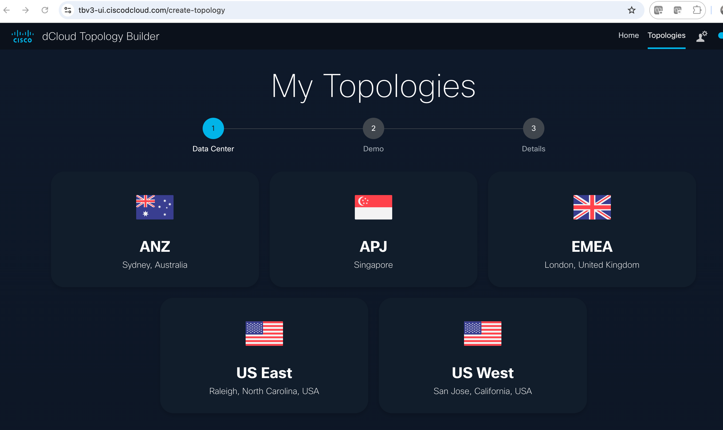

1. We’ll create a topology from scratch. Select Blank/Create from scratch

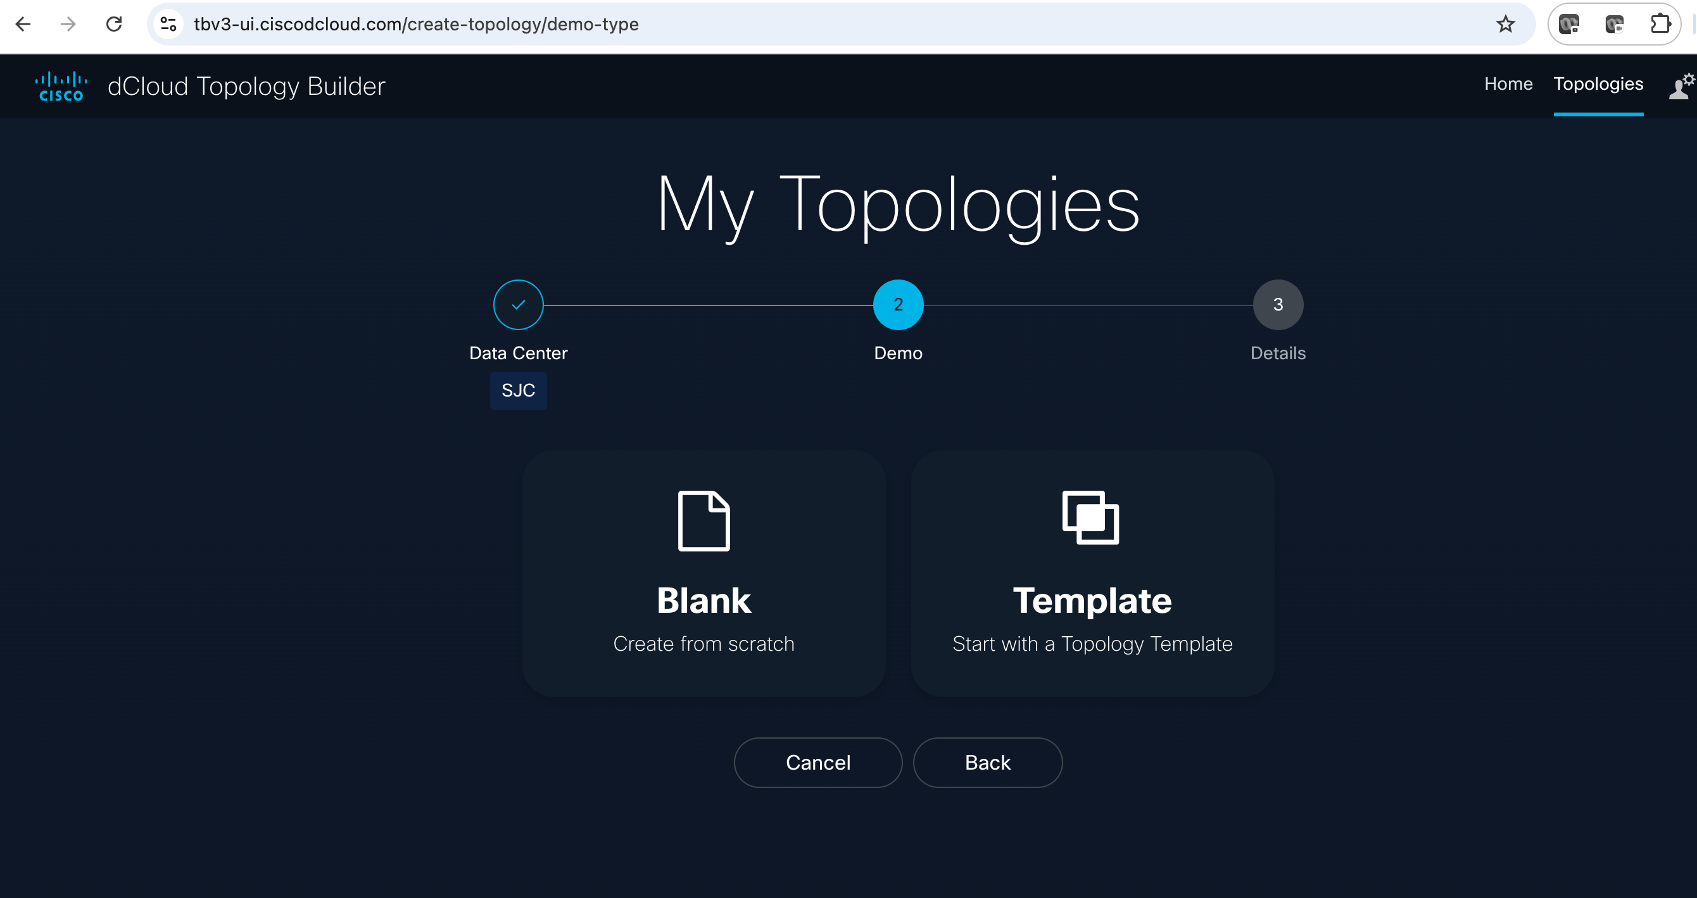

1. Give your topology a name, description, and click “create”

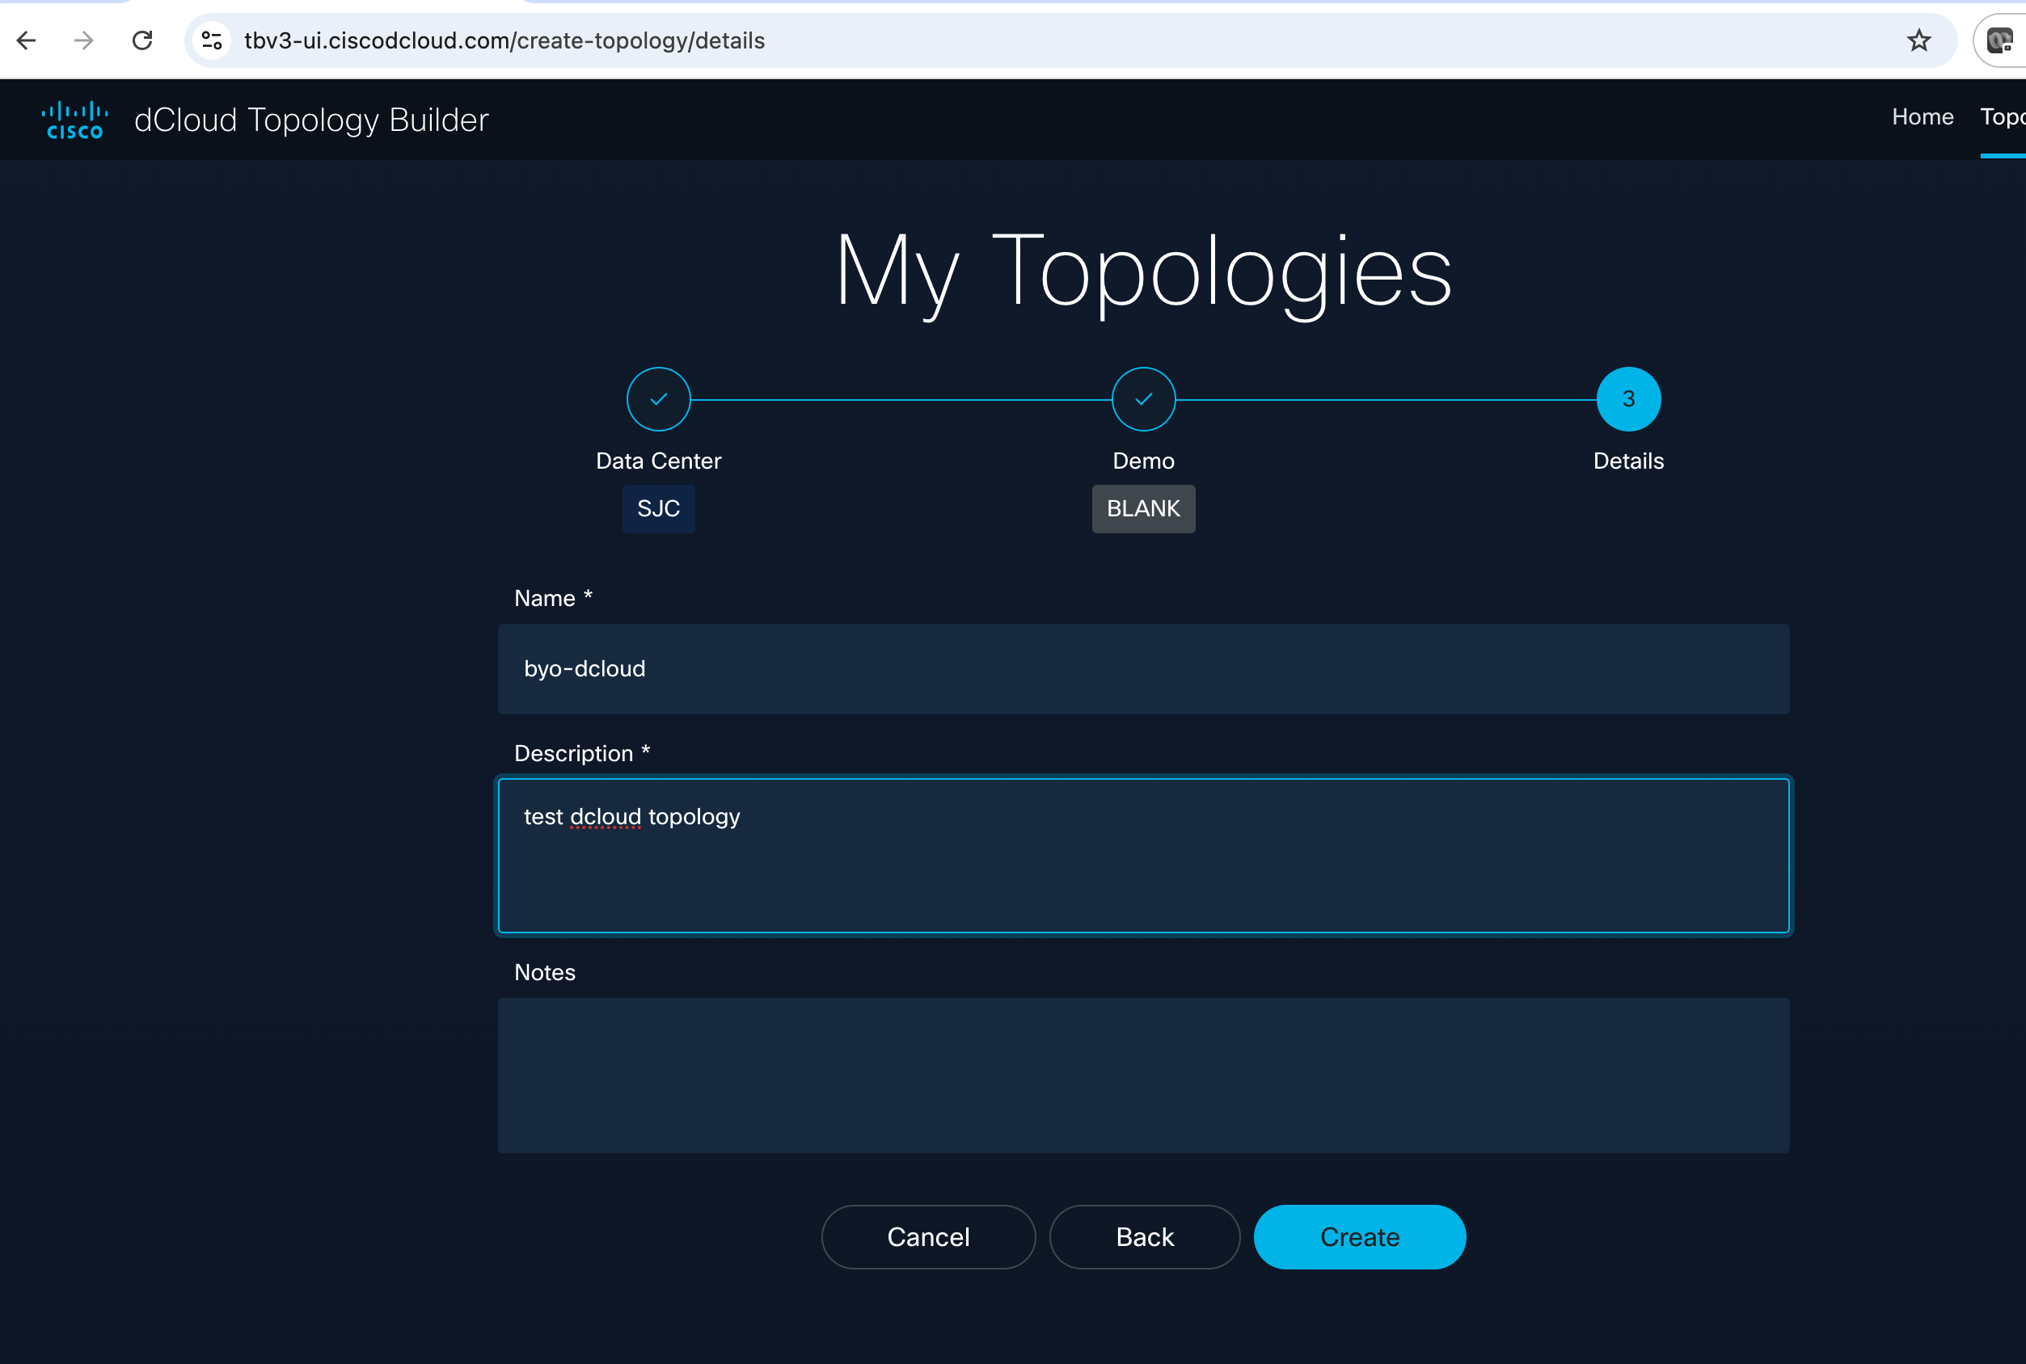

1. We’re going to build a very simple topology with one Big VM. Select “Virtual Machines”:

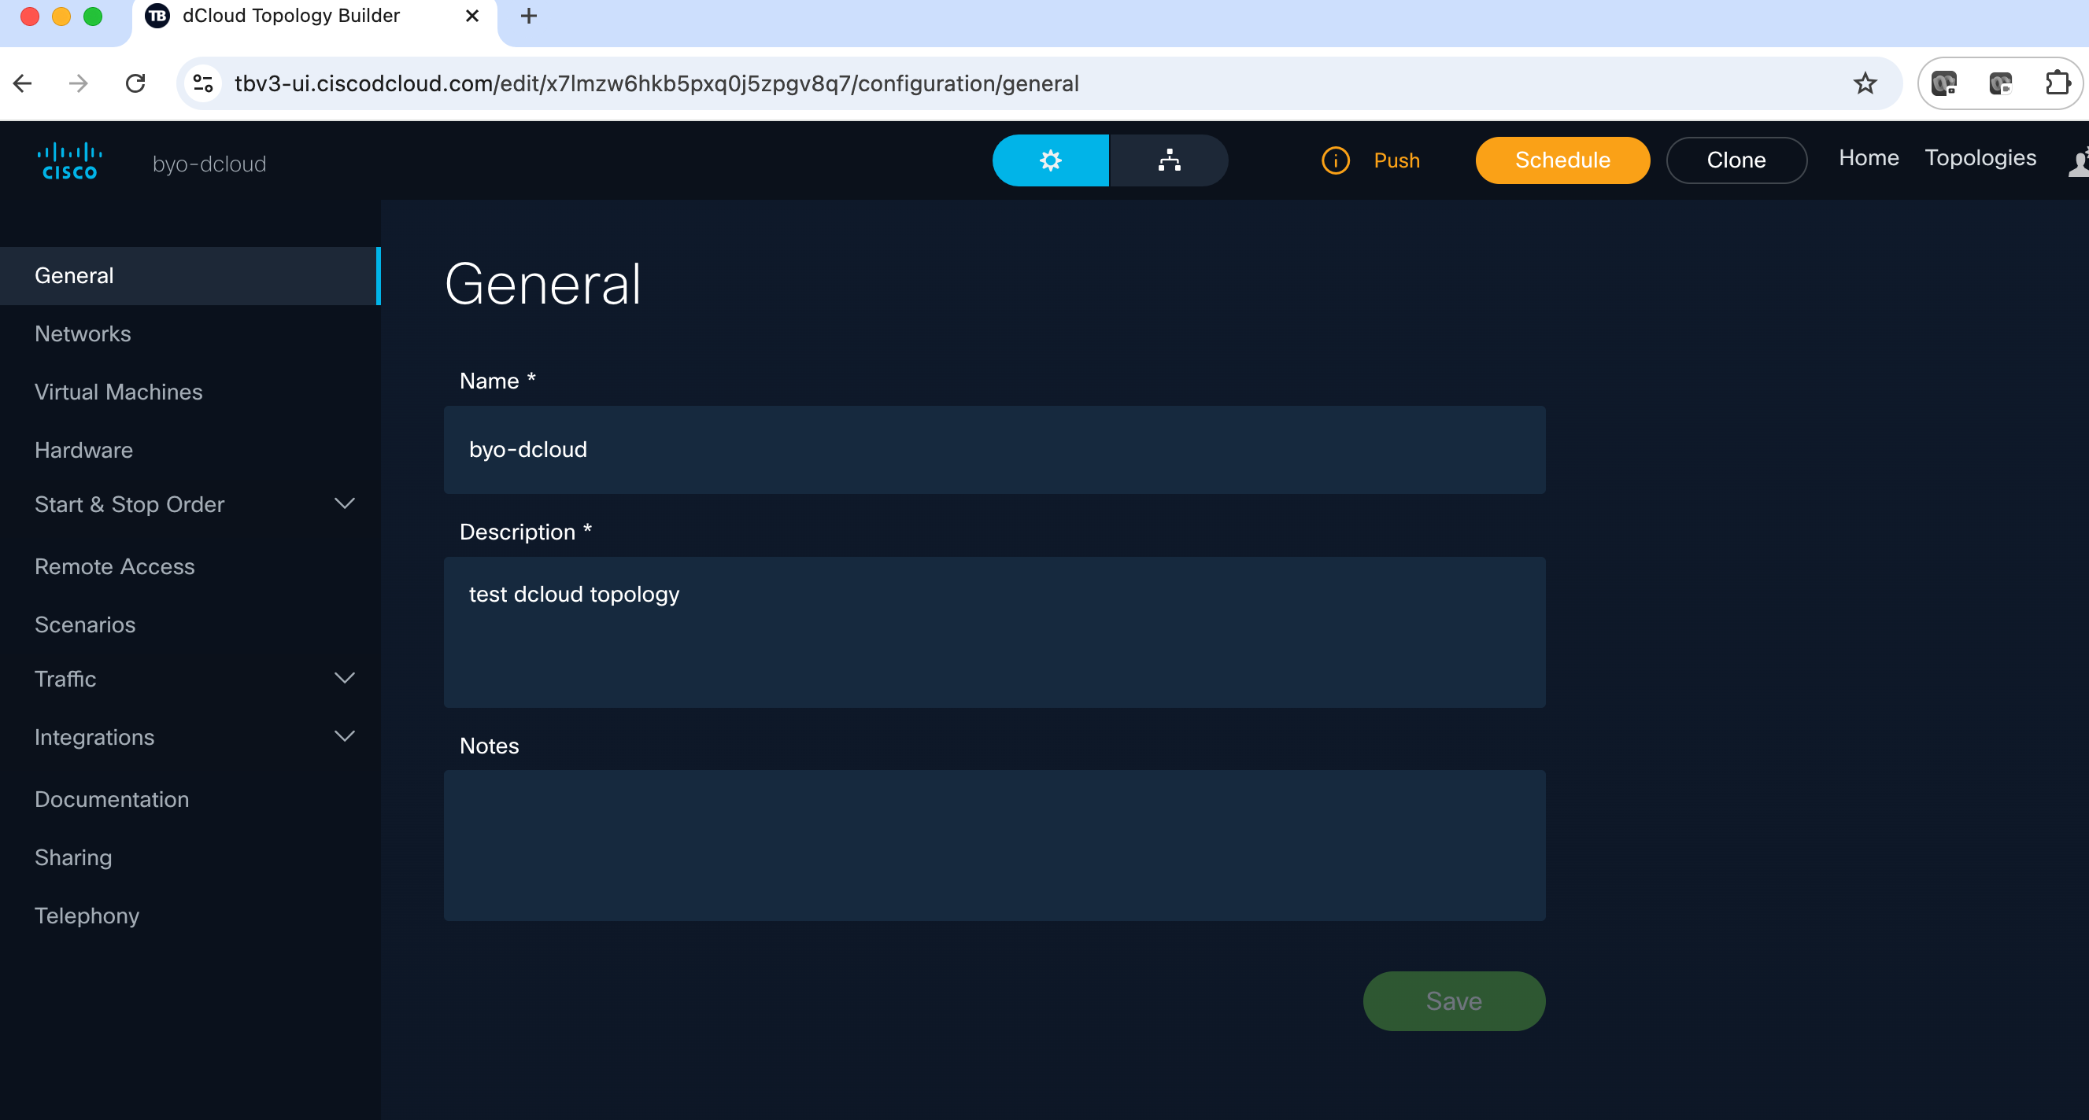

1. Select “New” to construct a new VM

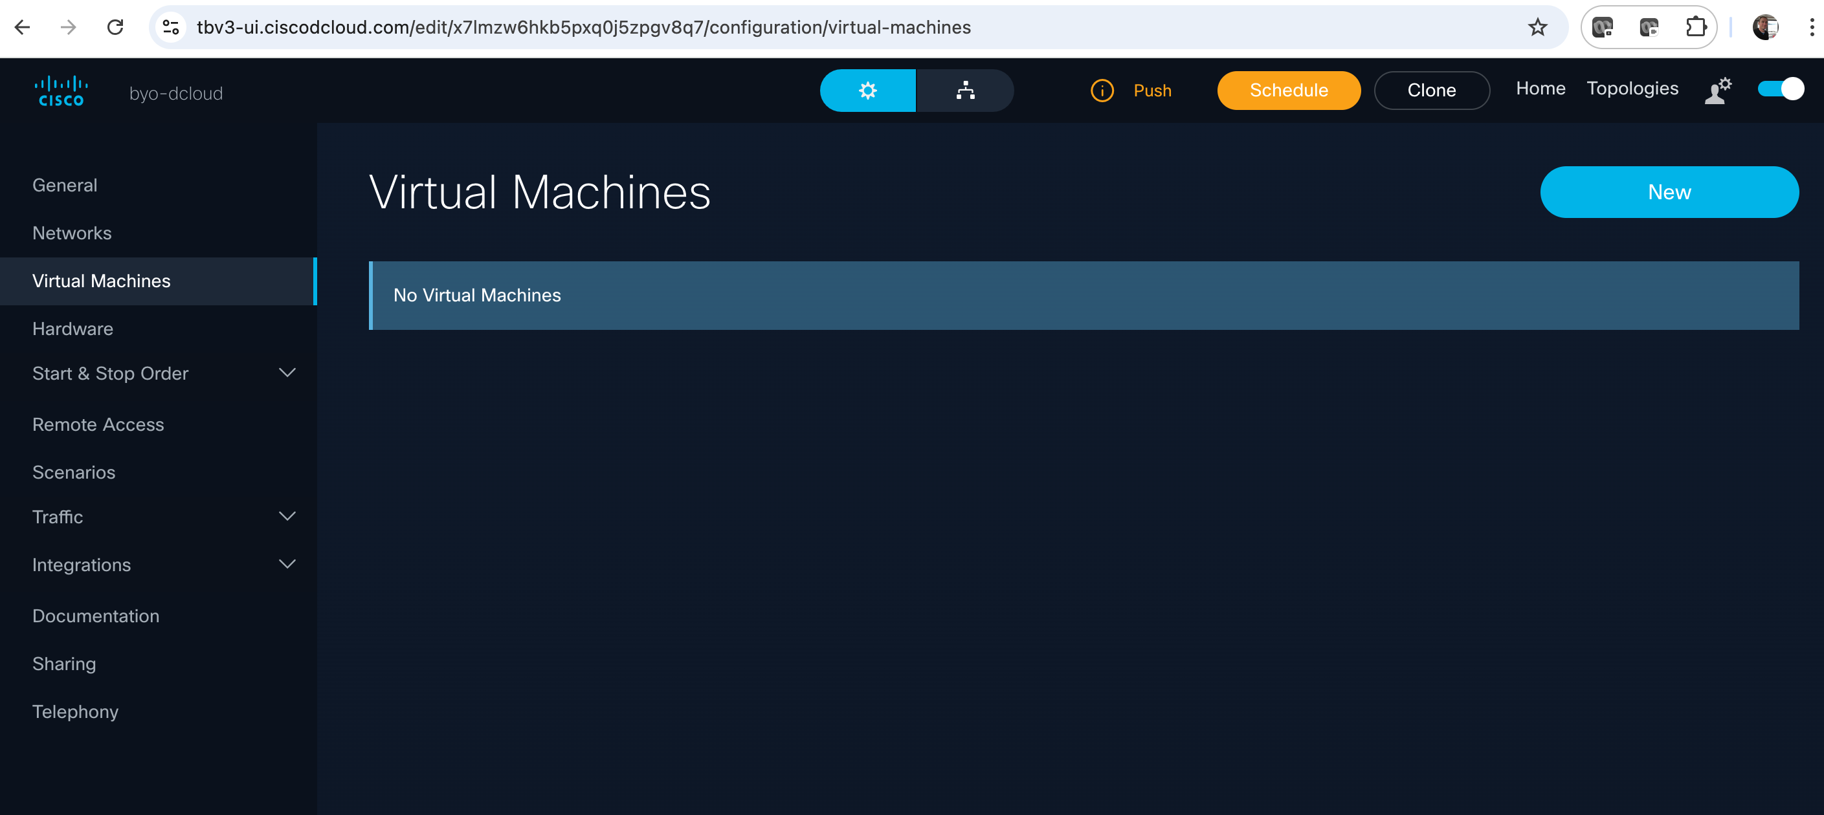

1. In the Add Virtual Machine screen do a search for “***ubuntu-22-04-server-80gb-preconfig***” (you can also search for just “ubuntu” to see other options

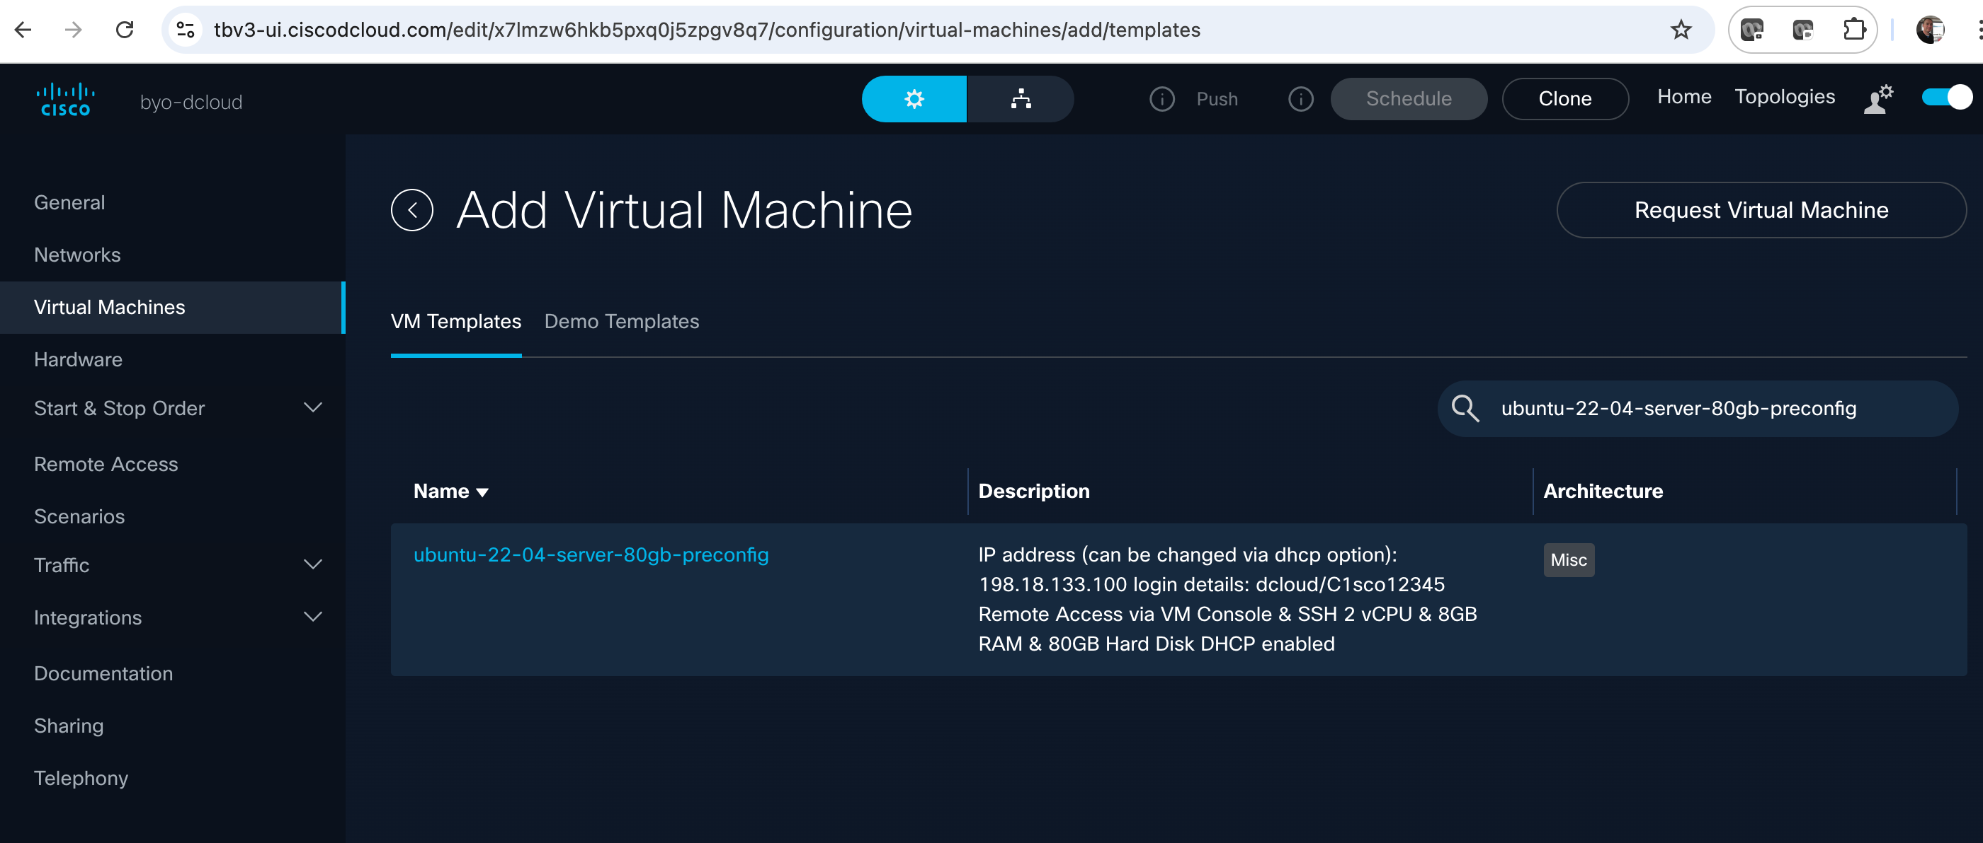

1. Select the Ubuntu 22 server VM template that comes up in search, then in the configure network screen select “Default Network” from the dropdown. Then click Add:

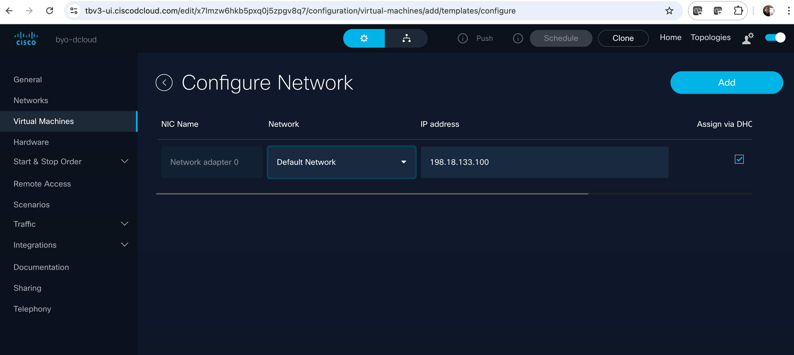

1. Your Virtual machine has been added. Now we want to edit it to increase memory and CPUs. Hover your mouse/trackpad to the right of the screen as shown…select the pencil thing to edit the VM parameters:

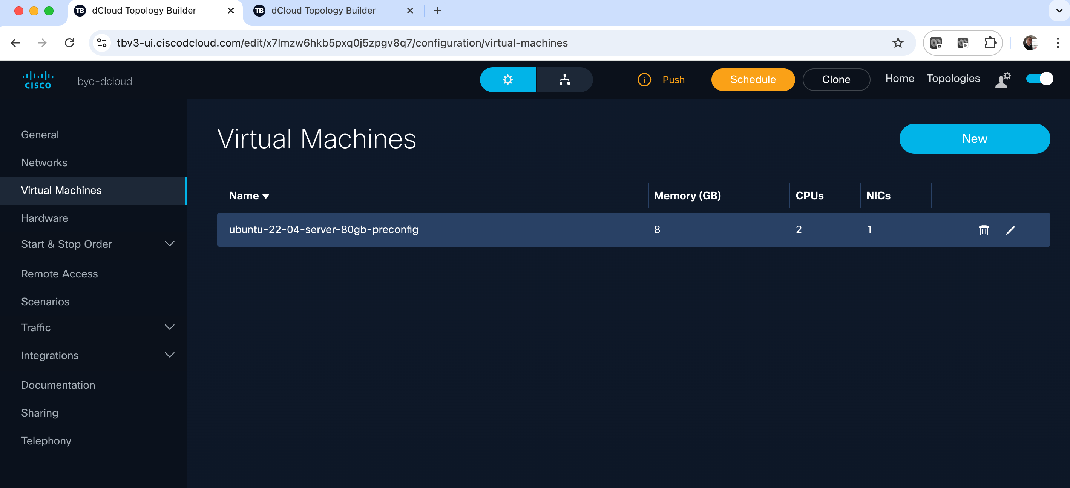

1. Change CPUs to 16 and Memory to 32. Note other options on this screen such as Nested Hypervisor (enable/disable) and Networking, etc. After editing CPU/Memory click “Update”

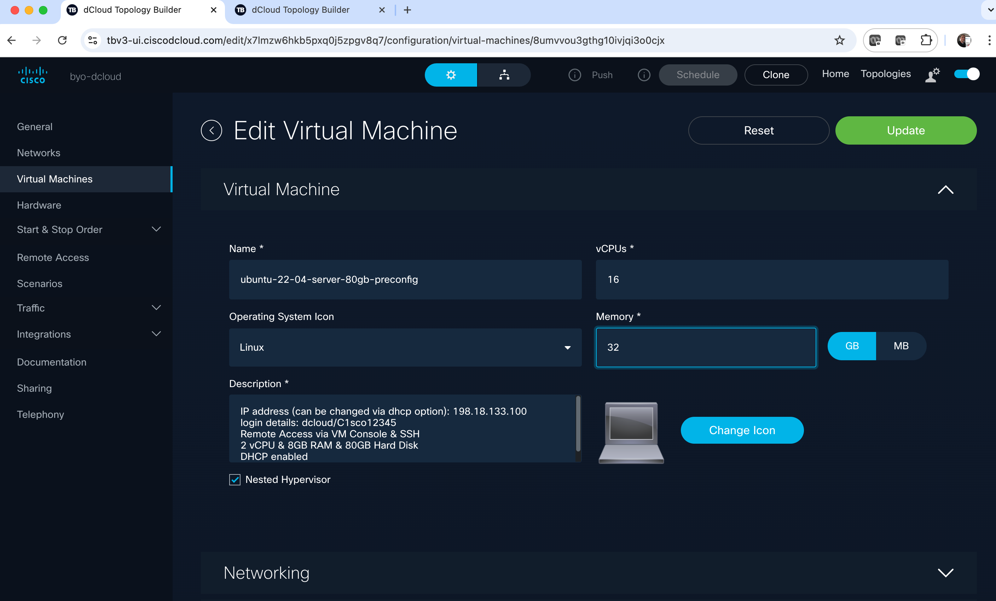

1. Go back to the “General” screen. You should see “Push” and “Schedule” lit up in Orange. Click “Push”

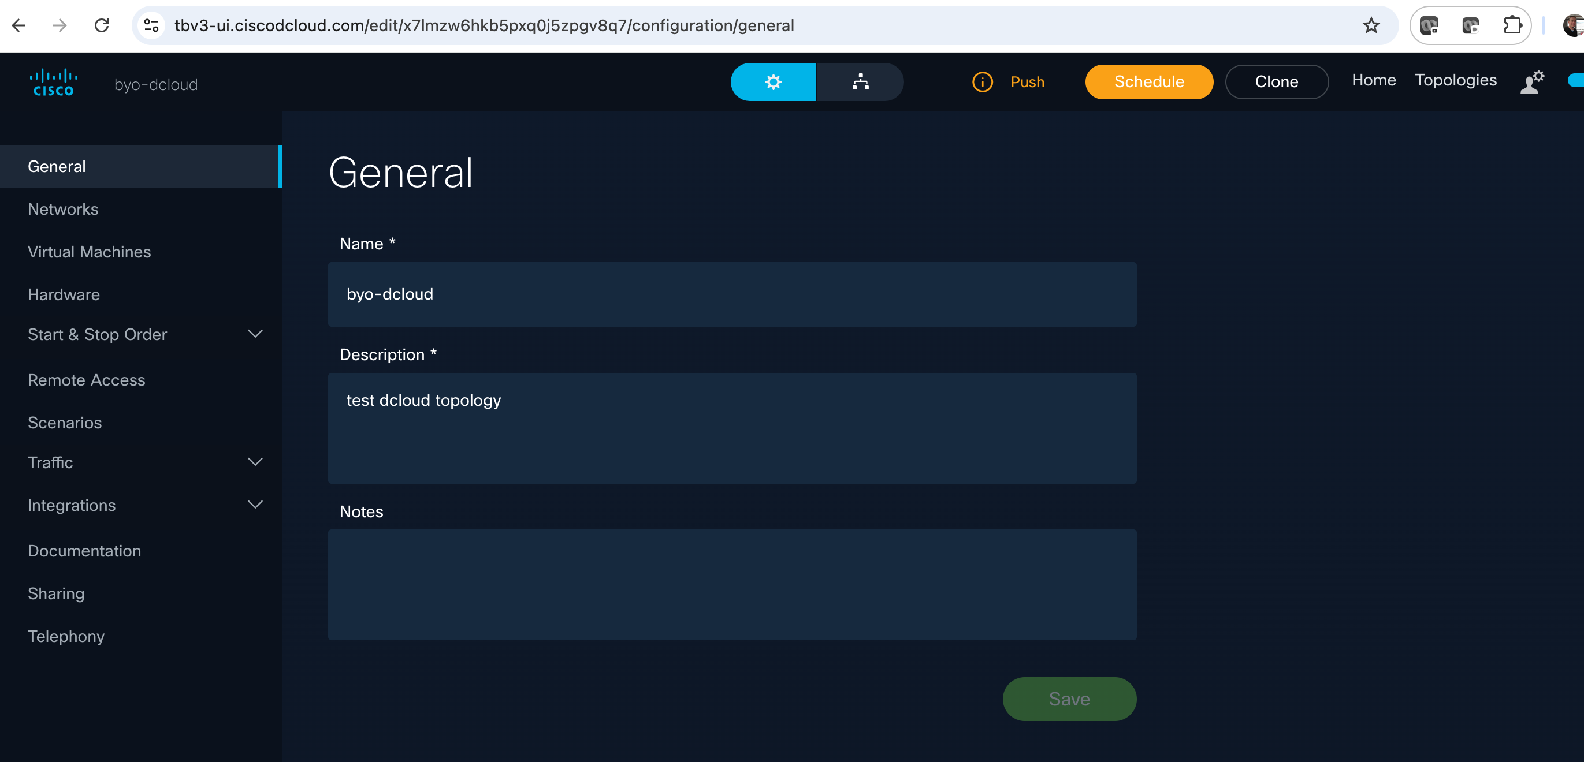

1. Click Save to push the topology template to your “Custom Content” on dCloud

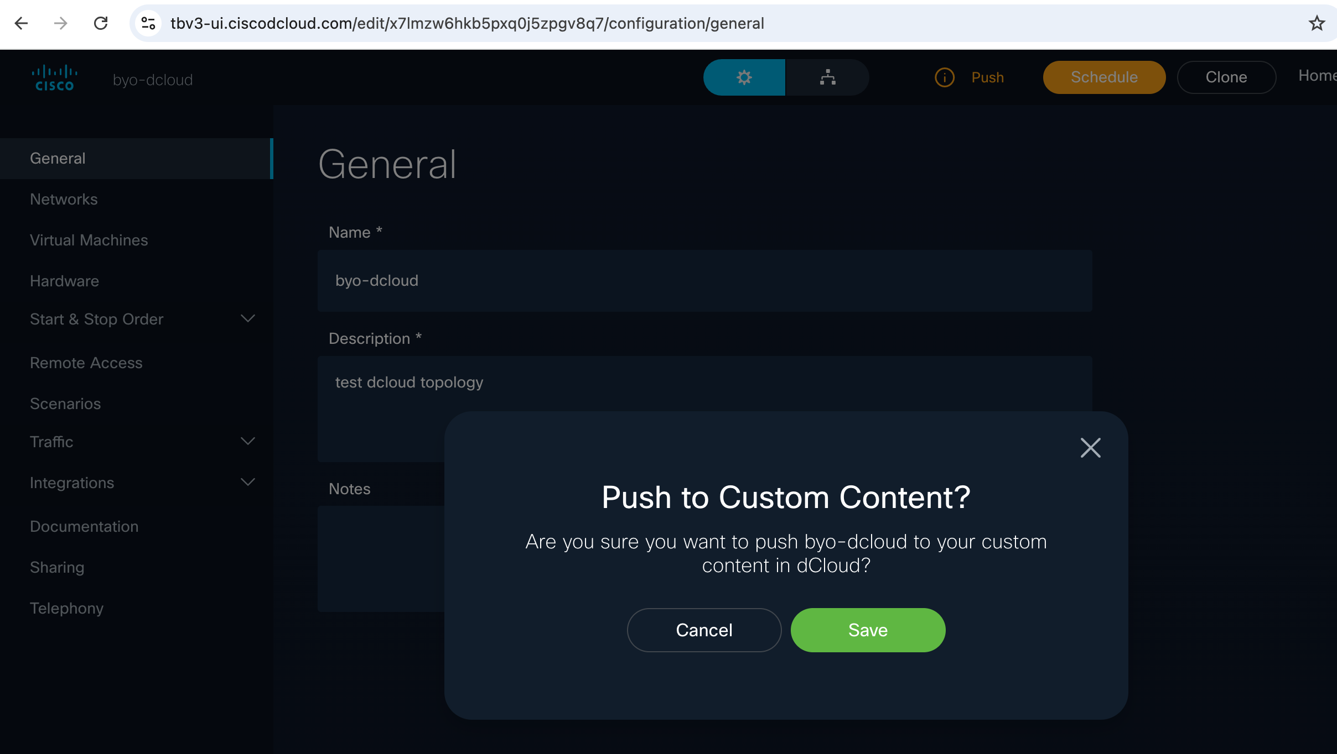

1. Your “topology” has now been pushed to dCloud (in this case SJC). For reference log into dCloud sjc or rtp:

<https://dcloud2-sjc.cisco.com/>

<https://dcloud2-rtp.cisco.com/>

1. Select “My Hub” at the top right, then “Custom Content” in the left side menu. Here you should see your session is ready to schedule.

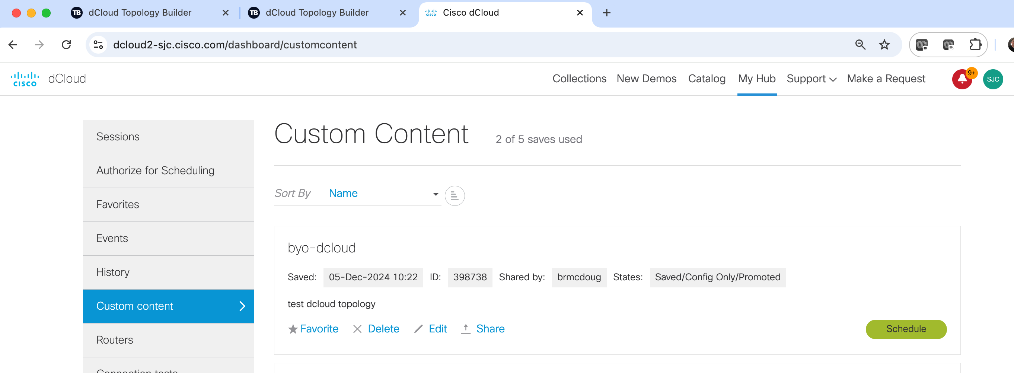

1. You can schedule the session from either the dCloud UI or the Topology Builder UI:

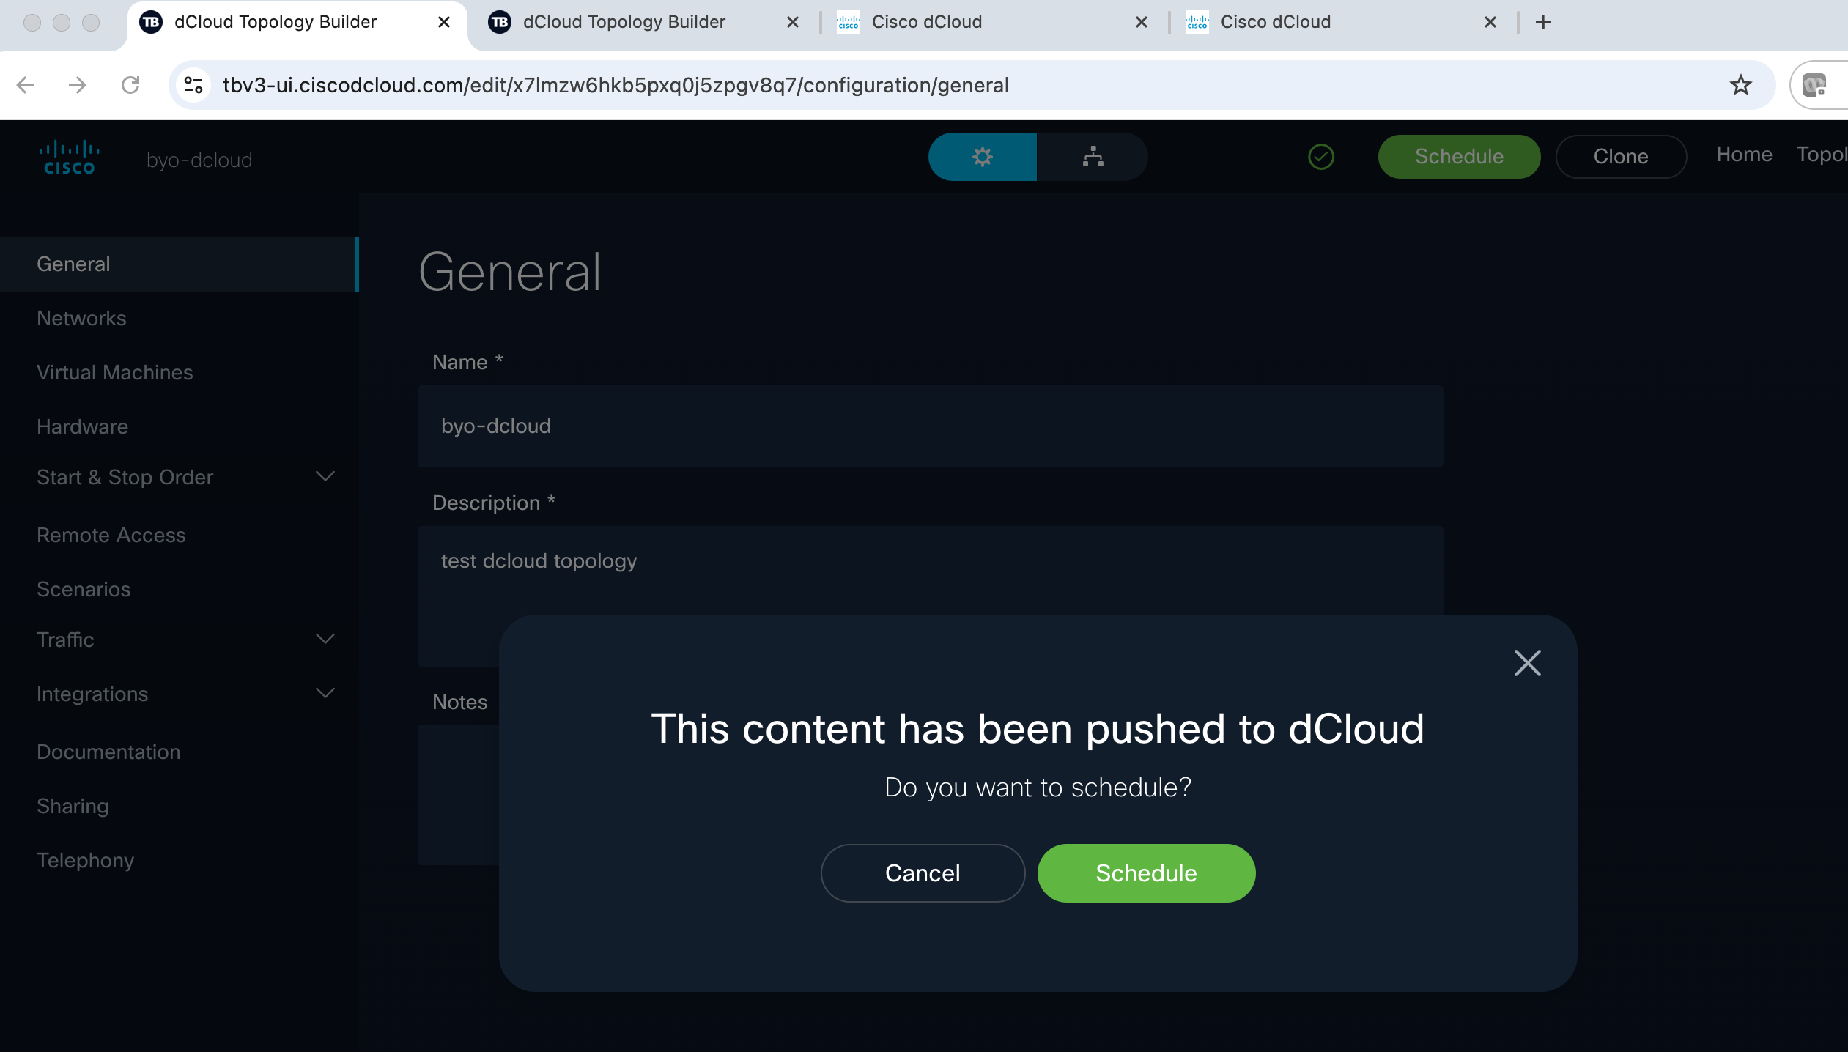

1. In the dCloud scheduling window, drag the bottom of the blue section down and across to schedule your session for a couple days, or simply click/edit the “End Date” and set it for a couple days out, then click Next

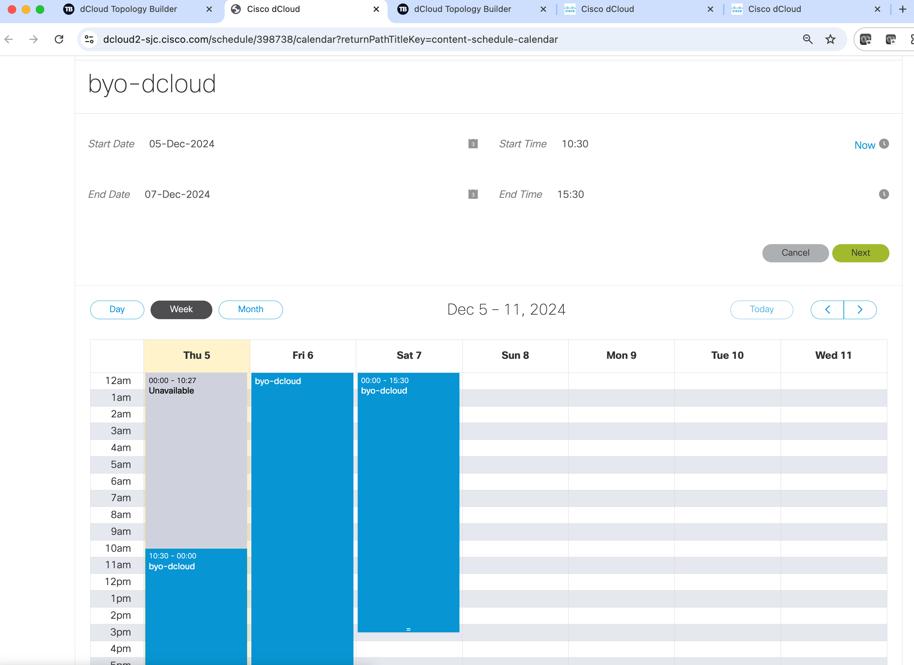

1. The “Please tell us how you will use this dcloud session screen”…Let “Primary Use” default to Customer Demo/Lab/POC/POV
2. For “Account Name – Country” enter the country where your customer is based. Then type in customer name. The tool should provide a drop down of options for customer location. Select one of them:

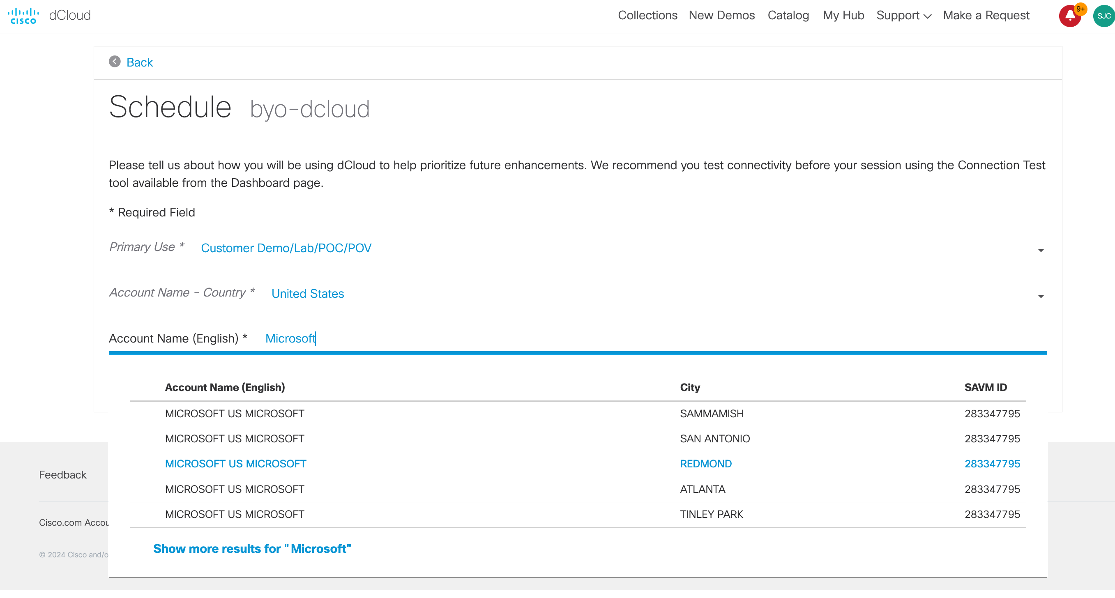

1. Click Schedule:

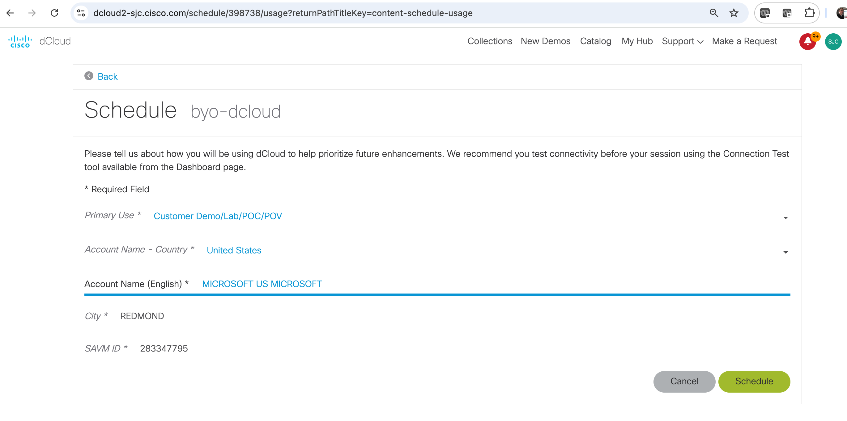

1. Your dCloud session will start at the time shown…we may get to wait a few minutes. ***Coffee break***

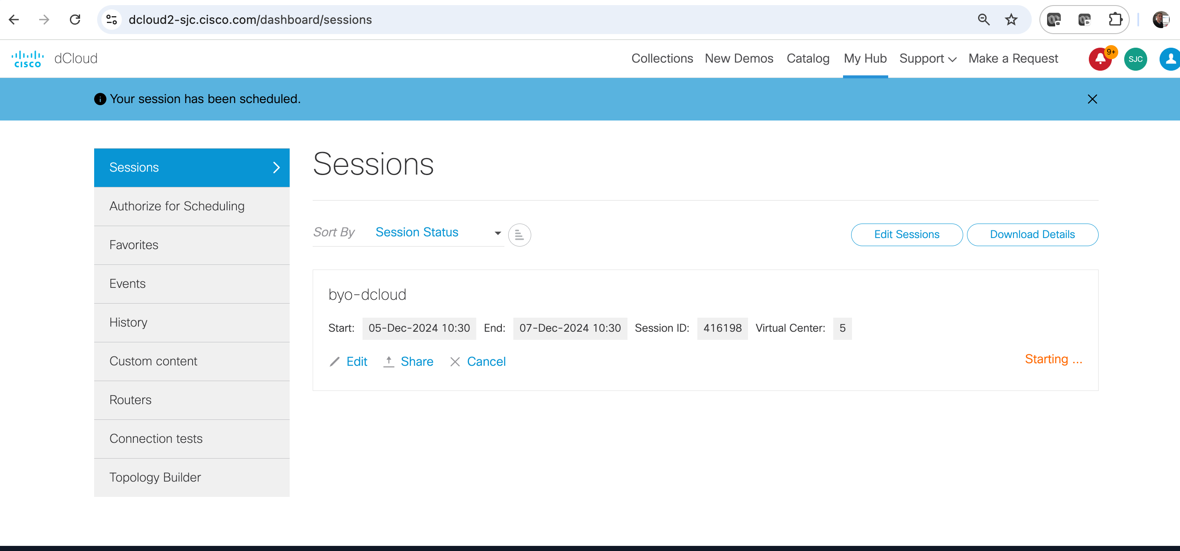

1. Once the Session has started, we can AnyConnect VPN in. Click “Info” then scroll down to AnyConnect Credentials.

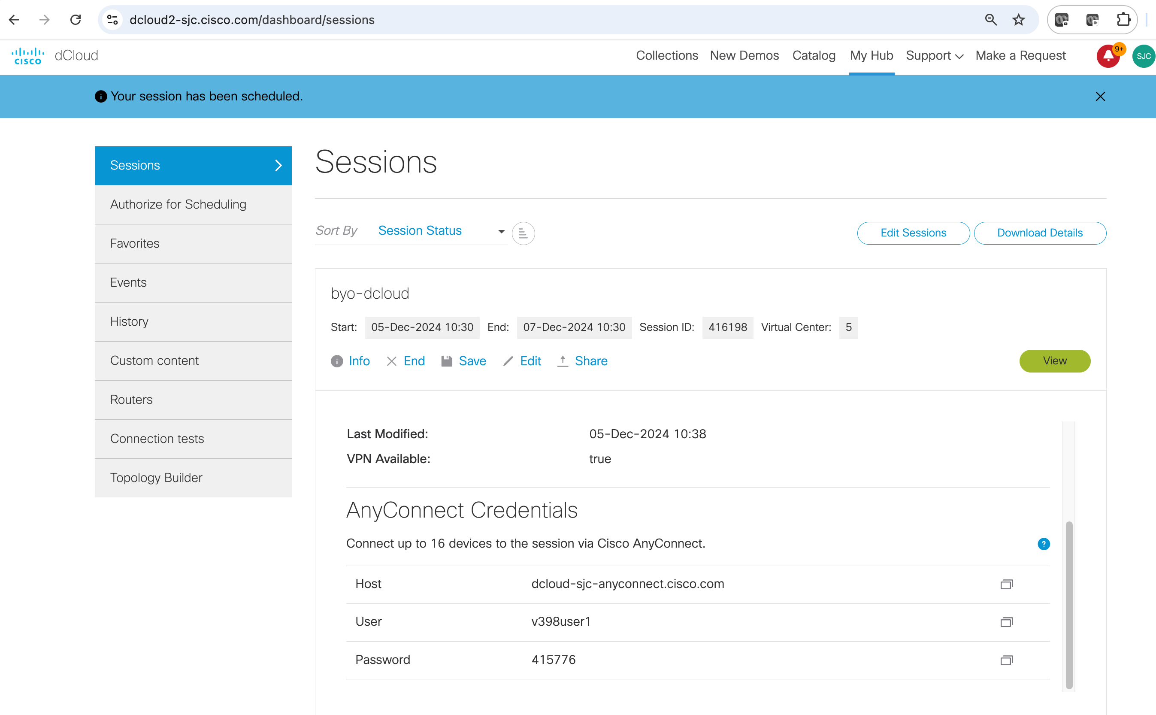

1. Optionally you can click the green View button, which will open a new topology view tab. Click “Info” and scroll down on the left-hand menu to see AnyConnect Credentials here as well:

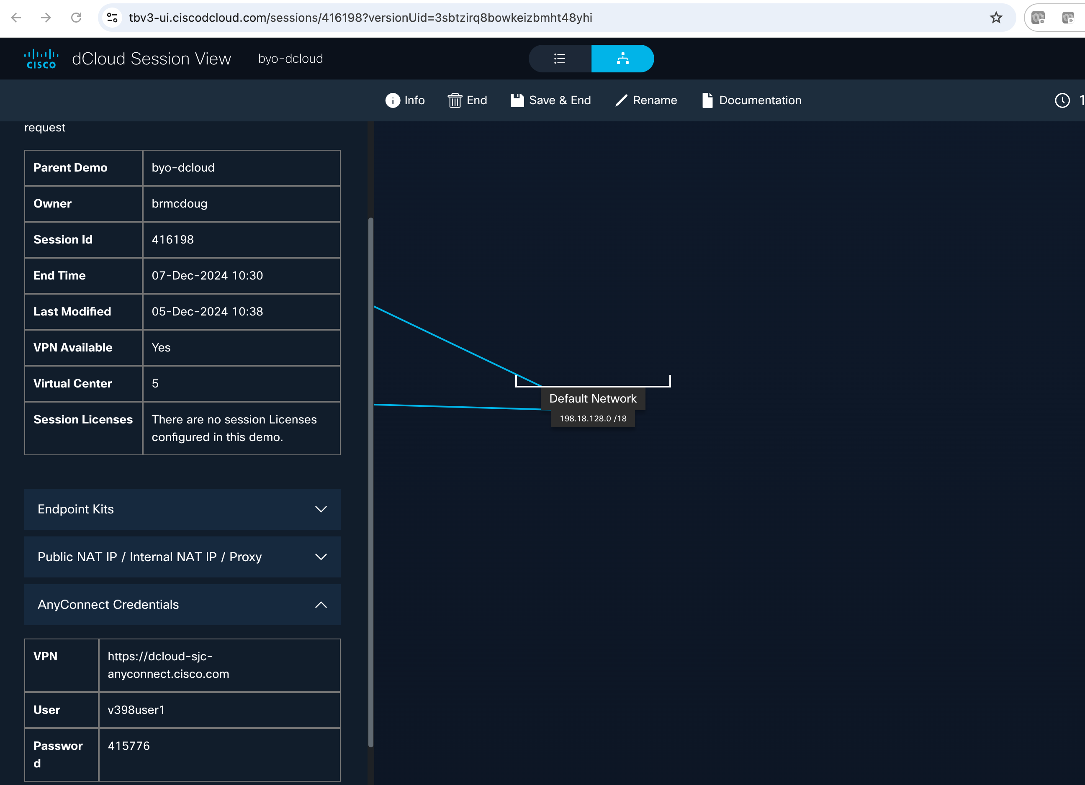

1. Fire up your VPN:

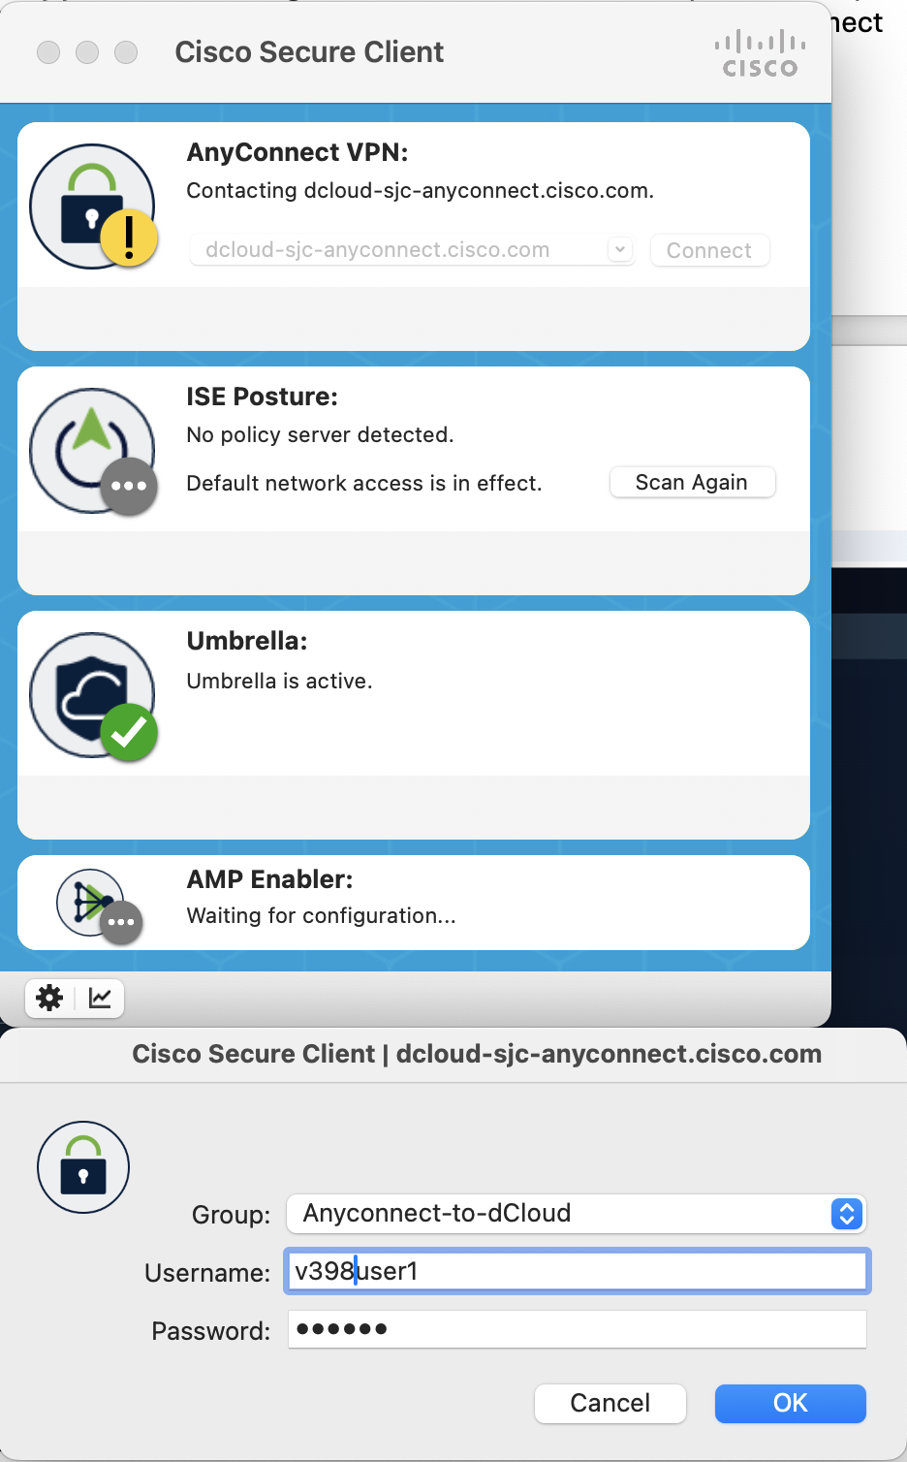

1. Once connected to VPN we can ssh to our Ubuntu VM.

**Ssh** [**dcloud@198.18.133.100**](mailto:dcloud@198.18.133.100)

**Password = C1sco12345**

## Part 2 – Everything else is ssh / CLI copy-paste from the lab README on Github:

<https://github.com/brmcdoug/byo-dcloud/blob/main/README.md#install-containerlab>